

**Al Maaref University**

**Faculty of Business Administration (FBA)**

**MIT 300**

**Information Systems and Technology**

**Private School**

Prepared by:

**Mohammad Ali Hamieh**

Supervisor:

**Dr. kassem Danash**

Fall semester

**2023-2024**

# 

# Dedication

Dear Dr. Bassam Hamdar, Dr. Kassem Danash, Dr. Hassan Rkein, and Dr. Ali El Dirani,

I hope this message finds each of you in the best of health and spirits. As our senior project draws to a close, I wanted to take a moment to express my deepest gratitude to each of you for your unwavering support, guidance, and expertise throughout this journey.

Your collective wisdom, dedication, and commitment to excellence have been the cornerstone of our project's success. Your willingness to share your knowledge and insights has not only enriched our learning experience but has also inspired us to strive for excellence in all that we do.

# Abstract

In a time of exponential technological growth, it’s interesting to think about educational institutions that intentionally choose to forgo technology in favour of more conventional approaches of instruction. Even though education has clearly changed in the digital age, some institutions are adamantly committed to using an analogue method. Technology in education has numerous advantages. It makes customised learning experiences possible, enabling teachers to adjust their lessons to the unique needs and learning preferences of each student. Simulations, instructional software, and interactive multimedia technologies improve understanding and engagement by simplifying and enjoying difficult ideas. This paper demonstrates a school system that assists in student registration, allows students to register for classes without physically attending class, and allows them to view the total amount they have spent for their education .Teachers can also know the timings of their courses and know how much the school paid them and how much remains.

I do this system using php language and access database.

## Recommendation:

This system makes it much easier for the school and students and allows them to work better.

Table of contents

Dedication 1

Abstract 2

Recommendation: 2

2.Background 3

3.Disruptive Technologies 6

3.1.What Is Disruptive Technology? 6

Disruptive technology is an innovation that significantly alters the way that consumers, industries, or businesses operate. A disruptive technology sweeps away the systems or habits it replaces because it has attributes that are recognizably superior. 6

Recent disruptive technology examples include e-commerce, online news sites, ride-sharing apps, and GPS systems. 6

In their own times, the automobile, electricity service, and television were disruptive technologies. 6

3.2.Disruptive Technology Explained 6

3.2.1.KEY TAKEAWAYS 7

3.3.Example on Disruptive Technology 7

4.Application of Disruptive Technologies: 9

4.1.Examples of how businesses are currently using these technologies and how they are benefiting from them: 9

4.1.1.3D printing: 9

4.1.2.Wearable tech : 10

4.1.3.Artificial intelligence: 10

4.1.4.Blockchain: 10

4.1.5.The Internet of things(IOT): 11

5.Case of a business that has successfully implemented disruptive technologies: 12

5.1.Challenges Faced by Amazon: 12

5.1.1. 12

5.1.2. 12

5.2.Benefits Gained by Amazon: 14

5.2.1. 14

5.2.2. 14

5.2.3. 14

6.Software 16

6.1.Software definition: 16

6.2. The benefits of software systems 17

6.2.1.Tactical benefits: 18

6.2.2.Strategic benefits: 19

6.3.Types of software 19

6.3.1. 5 types of systems software 19

6.3.2. 11 types of application software: There are many types of application software available. Here are 11 of the most common types: 22

7.Used technologies in my project: 26

7.1.Microsoft access database: 26

7.2.Php language: 27

7.3.Microsoft word: 27

7.4.Xampp: 28

7.5.Database Design: 28

The process of developing a comprehensive data model for a database is known as database design. In order to guarantee effective data storage, retrieval, and manipulation, it entails specifying the database's structure, including tables, columns, relationships, and constraints. Ensuring data security, performance, and integrity requires a well-designed database. 28

7.5.1.ERP: 29

Table of figures

Figure 1 29

Figure 2 30

Figure 3 31

Figure 4 32

Figure 5 33

Figure 6 34

Figure 7 35

Figure 8 36

# 1.Introduction

In an era where there is an unprecedented need for effectiveness and openness, the creation of a comprehensive system specifically designed for private education constitutes a significant breakthrough. This innovative project seeks to reduce the administrative burden that both students and school administrators bear by providing a comprehensive solution that facilitates the smooth integration of important stakeholders like doctors into the educational ecosystem, streamlines registration procedures, and offers detailed financial insights.

Fundamentally, this cutting-edge system transforms the way students engage with their educational experience by acting as a digital hub. The days of laborious paperwork and drawn-out registration procedures are long gone, and in their place, students now encounter an intuitive user experience that makes the enrolling process simple to navigate. The system provides a smooth and user-friendly experience for students to choose courses and pay for tuition, as well as submit necessary documentation. This gives students the confidence to take charge of their education.

Additionally, the system offers students a level of financial obligation clarity never before possible. Students may simply monitor their payment history, view their current amounts, and receive reminders for approaching deadlines via an advanced dashboard. This promotes financial responsibility and guarantees that students are aware of their financial situation in relation to the school community.

Simultaneously, this system provides school administrators with important capabilities that let them effectively handle student enrollment and financial information. Easily adding students, updating personal data, and tracking tuition payments allows administrators to improve resource allocation and administrative operations. Additionally, by offering a centralised platform for handling appointments, payments, and data, the system makes it easier for schools and outside parties to communicate smoothly, like physicians or other medical professionals.

This senior project is a big step towards rethinking the operational dynamics of private schools because it uses technology to improve communication and streamline administrative procedures. In the end, it opens the door for a more simplified, transparent, and enriching educational experience for all parties concerned since it represents a dedication to creativity, efficiency, and student-centricity.

# 2.Background

The field of management information systems (MIS) is situated between the fields of computing and business. The field of management information systems (MIS) is becoming more and more significant as it helps businesses transition from paper-based to computerised systems. Employees with knowledge across business areas, such accounting, finance, and marketing, as well as computing and information technology domains, like software development, data science, and networking, are needed for the digital transformation of corporate data and operations. Students majoring in MIS are equipped to help businesses digitise tasks and manage a workforce that is becoming more and more distant. Students can specialise in the field of management information systems (MIS) because IT is present in many organisational units and facets of daily life. Students with an interest in data, for instance, can concentrate on learning how to collect, store, and evaluate corporate data. Among the key duties of MIS specialists are database administration and business analytics. Programming-interested students might concentrate on managing and collaborating with computer scientists to build and develop software that meets the demands of business professionals. Students who are interested in corporate operations and strategy might concentrate on how information technology can be used to improve operations and make them safer, more effective, and efficient.

In order to design or use computerised systems for a certain business sector, such as accounting systems, financial systems, and marketing systems, students might concentrate on various business topics. The field of MIS offers a wide range of career options. Those that enrol in MIS programmes are also more equipped to manage projects and embrace technology strategically. MIS specifically trains people to oversee information technology initiatives. Students learn how to manage projects in an agile manner to assist organisations in maintaining cutting-edge computer systems that support business processes because information technology is a field that is always changing. Making well-considered decisions is necessary when implementing or creating computerised systems to digitise and automate corporate activities. Pupils gain the ability to evaluate the technologies' business worth as well as the organisations' readiness to use new IT. particular information technologies may not be ready or feasible for particular organisations to use, depending on the business environment. In order to develop technological capabilities within companies, MIS specialists evaluate developing technology and the business environment.

As an antiseptic and antidote to address and support informed decision-making within organisations, management information systems (MIS) are viewed as an essential tool in the business landscape. In order to provide system users with reliable, complete, accessible, and understandable data in a timely manner, companies and businesses are encouraged to take a proactive approach to data analysis. Additionally, it helps to improve performance, client satisfaction, work reliability, and organisational productivity. The application of management information systems (MIS) facilitates the gathering, retaining, processing, and storing of crucial data and makes decision-making processes easier in the context of e-commerce and digitalized enterprises. Businesses rely on management information systems (MIS) to streamline decision-making processes, as is obvious from modern culture. Businesses frequently turn to outdated techniques or manual systems for data storage due to the difficulties they have in maintaining and preserving their data. This article focuses on using management information systems (MIS) to improve operational operations by enabling organisations and enterprises to make well-informed decisions. In addition to outlining the main ideas of management information systems (MIS), this article also emphasises the importance of MIS in relation to business operations and lists a number of potential career paths in the area.

# 3.Disruptive Technologies

## 3.1.What Is Disruptive Technology?

## Disruptive technology is an innovation that significantly alters the way that consumers, industries, or businesses operate. A disruptive technology sweeps away the systems or habits it replaces because it has attributes that are recognizably superior.

## Recent disruptive technology examples include e-commerce, online news sites, ride-sharing apps, and GPS systems.

## In their own times, the automobile, electricity service, and television were disruptive technologies.

## 3.2.Disruptive Technology Explained

Disruptive technologies were first conceptualised by Clayton Christensen in a 1995 paper published in the Harvard Business Review. 1. Afterwards, in 1997, Christensen went into further detail on the subject in The Innovator's Dilemma. 2. Since then, it has been a catchphrase for fledgling companies looking to develop a widely appealing product. A startup with less funding can still aim for technological disruption by creating a whole new method of doing a task. Well-established businesses typically concentrate on their areas of expertise and strive for small, gradual advancements rather than radical shifts. They serve their biggest and most picky clientele.

### 3.2.1.KEY TAKEAWAYS

Disruptive technologies replace outdated procedures, goods, or behaviours. They typically have better features that are instantly apparent, at least to early adopters.Disruptive inventions typically originate from startups as opposed to well-established businesses. This gives disruptive enterprises a chance to establish a presence in the market and target underserved customer categories. Well-established businesses frequently lack the adaptability to promptly respond to emerging risks. As a result, disruptors are able to gradually creep upstream and devour larger consumer sectors. Because disruptive technologies can emerge quickly, it might be challenging to plan for them.

## 3.3.Example on Disruptive Technology

The technology underlying Bitcoin, known as blockchain, is a decentralised distributed ledger that keeps track of trades between two parties. It transfers transactions to an open cryptography network from a centralised server-based system. The system eliminates the need for manual verification by recording and verifying transactions through peer-to-peer consensus. In its own right, the vehicle, the power grid, and television were revolutionary inventions. Financial organisations like banks and stock brokerages will be greatly impacted by blockchain technology. By doing peer-to-peer trade confirmations on the blockchain, for instance, a brokerage business may do away with the need for custodians and clearinghouses, cutting expenses associated with acting as financial intermediaries and significantly speeding up transaction times.

# 4.Application of Disruptive Technologies:

When a new, cutting-edge technology disrupts an industry, business, or consumer's way of life, it has the ability to replace or completely revolutionise long-standing customs. Start-ups are frequently the source of disruptive innovations, which enable them to become market leaders in new areas or to take a sizable grip in established industries.

# 4.1.Examples of how businesses are currently using these technologies and how they are benefiting from them:

Blockchain, wearable technology, artificial intelligence, 3D printing, and the Internet of Things are examples of recent disruptive technologies (IoT).

## 4.1.1.3D printing:

Digital data can be used to produce three-dimensional items via additive printing, also referred to as 3D printing. Numerous industries, including the automotive, manufacturing, aviation, and medical sectors, use it. Versatile and reasonably priced, 3D printing is a great option. It provides the opportunity to generate prototypes without the need to create costly dies and moulds, which can reduce the turnaround time in prototype production. More customisation is another benefit of 3D printing, and since it prints only what is needed, there is less need to keep extra inventory on hand.

## 4.1.2.Wearable tech :

Smart devices that are worn on the body, such watches and spectacles, are referred to as wearable technology. It frequently has sensors built in that allow data interchange with mobile apps and the Internet. Continuous real-time data collection, such as heart rate, calories burned, and daily steps, is made possible by wearable technology. An understanding of an individual's general health can be gained from these statistics.

## 4.1.3.Artificial intelligence:

Artificial intelligence (AI) finds application in a multitude of domains, such as video games, email spam filtering, and fraud detection. AI enhances people's lives and makes company operations more effective. It is utilised in virtual assistants like Apple Siri and Google Home as well as chatbots for online help.

## 4.1.4.Blockchain:

Designed to upend the banking sector, blockchain spreads its ledger over several devices via a decentralised network. Its decentralisation, transparency, and security are its three main characteristics. These seek to reduce expensive bank fees while enhancing the security of financial transactions. Fast transactions are another benefit of blockchain, which is unrestricted by a single authority.

## 4.1.5.The Internet of things(IOT):

The vast network of gadgets linked to the Internet is known as the Internet of Things. It contributes to closing the gap between the physical and digital domains. IoT makes it easier to build new connections, permits data sharing, and might play a crucial role in the supply chain process. It can be utilised for many different things, like equipment maintenance and efficiency and productivity tracking.

# 5.Case of a business that has successfully implemented disruptive technologies:

Amazon is a well-known company that has effectively incorporated disruptive technologies. Throughout history, Amazon has revolutionised a number of industries, most notably e-commerce, cloud computing, and logistics, by utilising disruptive technology. One of their most well-known disruptive inventions is Amazon Prime, a membership club that provides quick shipping, streaming content, and a host of other advantages.

## 5.1.Challenges Faced by Amazon:

5.1.1. Logistics and Delivery: Streamlining their network of logistics to provide clients with quick and dependable shipment throughout the globe was one of Amazon's largest problems. This meant making large investments in operations, technology, and infrastructure.

5.1.2. Data management: One of the biggest challenges was keeping track of and evaluating the enormous volumes of data that their e-commerce platform and consumer interactions produced. In order to extract valuable insights and customise consumer experiences, Amazon need strong machine learning and data analytics skills.

5.1.3. Competition and Market Disruption: Other e-commerce firms and well-established merchants posed a serious threat to Amazon. Another major problem was persuading customers to change their purchasing habits to the internet and upending established retail patterns.

**How Amazon Overcame These Challenges:**

Investment in Technology: Cloud computing, robots, artificial intelligence, and other technologies have all seen significant investments from Amazon. To optimise transport routes and warehousing operations, for instance, they created sophisticated algorithms that lower costs and increase efficiency.

Put Customer Experience First: By consistently enhancing their website, mobile app, and shipping services, Amazon has put the needs and convenience of their customers first. To improve the shopping experience, they developed innovations including same-day delivery, personalised recommendations, and one-click purchasing.

Vertical Integration: By making investments in a number of supply chain components, such as fulfilment facilities, delivery services, and logistics, Amazon has vertically integrated its operations. They were able to increase their control over the whole value chain and streamline procedures to cut costs and increase efficiency as a result.

## 5.2.Benefits Gained by Amazon:

5.2.1. Market Leadership: Amazon has risen to the top of the e-commerce, cloud computing, digital streaming, and smart device (Amazon Echo) markets by adopting disruptive technologies and never stopping inventing.

5.2.2. client Loyalty and Retention: With its quick shipping, exclusive offers, and streaming services, Amazon Prime has contributed to the development of client loyalty. High customer retention rates and enhanced customer lifetime value can be attributed to the convenience and value that Prime offers.

5.2.3. Operational Efficiency and Cost Savings: Major advancements in operational efficiency and cost savings have resulted from Amazon's investments in technology and logistics. Even during busy times, they can efficiently and swiftly complete orders thanks to their advanced supply chain management systems and fulfilment centres.

To sum up, Amazon's effective application of disruptive technology shows how companies may innovate, overcome obstacles, and prosper in cutthroat markets. Amazon has transformed numerous industries and established new benchmarks for excellence in e-commerce and digital innovation by concentrating on the requirements of its customers, investing in technology, and streamlining operations.

# **6.Software**

## 6.1.Software definition:

Software is the set of instructions that directs a computer. Software is the totality of the routines, processes, and programmes involved in running a computer system. The phrase was created to set these instructions apart from hardware, or the actual parts of a computer system. A software programme is a collection of instructions that tells a computer's hardware how to do a certain task.

System software and application software are the two primary categories of software. System software manages peripherals like monitors, printers, and storage devices in addition to the fundamental operations of a computer, which are primarily controlled by the operating system. On the other hand, application software is any programme that handles data processing on behalf of a user and instructs the computer to carry out directions from the user. Thus, word processors, spreadsheets, database management, inventory and payroll software, and numerous more "applications" are examples of application software. Network software, which manages communication between the machines connected in a network, is a third type of software.

Usually, software is kept on an external long-term memory device, like a magnetic diskette or hard drive. The computer reads the programme from the storage medium and temporarily stores the instructions in random access memory (RAM) while it is in use. "Running," or "executing," a programme refers to the act of storing the instructions and subsequently carrying them out. Firmware, also referred to as "hard software," is the term for software applications and processes that are read-only (ROM) technologies and are permanently stored in a computer's memory.

## 6.2. The benefits of software systems

It's not always simple to determine which new software brings which advantages. The person (or individuals) thinking about introducing or expanding a software system (we'll refer to them as the "customer") could be quite excited about the potential advantages of the new software, including giving them "more control" and "better service." Nevertheless, the benefits of the new software can be very hard to measure, since it is improbable that the current (manual or partially software-based) approach is destroying a company. In actuality, the programme might not even have any overall advantages if it is poorly developed and poorly thought out.

Many firms are motivated to look into developing new or expanded software systems for their operations due to the potential for major benefits and the differences information systems have made in other organisations.

Because organisations, their information systems, and the software they use are complex, it is difficult to quantify and evaluate the costs and advantages of developing information systems and software. These systems are challenging to evaluate, create, and operate. This is the reason that a lot of research has been done on the interaction between software and information systems in companies as well as on the development of software and information systems. Potential advantages can be broadly categorised into two groups:

• tactical advantages

•strategic advantages

### 6.2.1.Tactical benefits:

Benefits that are quantifiable and enhance an organization's or group's daily operations are known as tactical benefits. Consumers nearly always expect or demand cost-benefits from new software and systems. Sometimes an automated system is replaced by software, but the new software has less expensive hardware and requires less maintenance. For example, when a network of smaller PCs takes the role of a single, centralised computer system. Alternatively, if a manual method is replaced by a software system, savings on paper, filing cabinets, and office space may result. There can be an increase in communication that leads to a decrease in phone calls and faxes. There can be a reduction in the amount of employees needed in both situations to maintain the outdated

The precision and speed of software systems are further advantages that are often mentioned. Data can be obtained more rapidly and with more assurance regarding its correctness. Employee productivity may increase as a result. Additionally, it can enhance the flow of goods and their availability to consumers. An organisation might be able to handle more transactions as a result, growing its business.

### 6.2.2.Strategic benefits:

Enhancing a group or organization's capabilities is the goal of strategic benefits. A company could be able to provide new services to its clients with the help of a new software system. Alternatively, new customers or items could be identified by looking through the information stored. More hypothetically, improved capability may enable managers to spot spending or sales trends fast. This can provide you a market advantage over your competitors. Expert systems have made it possible to disseminate and make information that was previously limited to a small number of people throughout an organisation. This could have a number of positive effects on how well a business operates. Nevertheless, without careful planning, strategic gains are often much harder to measure than tactical ones.

## 6.3.Types of software

### 6.3.1. 5 types of systems software

Systems software are the programs that allow a computer system to operate. Here are five common types of systems software:

6.3.1.1.operating system

System environments The main computer system that enables a computerised device to function is called an operating system. In addition to providing protocols for installing and using apps on the device to enable functionality, the operating system enables the device to start up. Operating systems can be tailored to a specific device, as an operating system for a computer or a mobile device. Usually, they are proprietary operating systems that a firm develops for use in its products or that are made accessible to the public or that can be licenced for use by other manufacturers.

6.3.1.2. Device driver

Device driver An operating system and a hardware device can communicate with each other thanks to computer programmes called device drivers. The operating system's driver instructs the system on how to communicate with hardware. Printers, scanners, card readers, and modems are a few examples of devices that need drivers in order to function with an operating system. When installing new hardware or updating to the most recent driver edition, drivers can be downloaded from the internet. New hardware attachments typically install and update drivers automatically.

6.3.1.3. Firmware

Configuration A sort of systems software called firmware instructs a hardware component on how to function. In contrast to drivers, which are a component of the operating system, firmware is embedded in the hardware and works in conjunction with them to ensure that it functions as intended. The majority of computer hardware, including hard drives, routers, displays, and peripherals, include firmware.

#### 6.3.1.4. Programming language translator

creating a language translation programme A form of systems software called a compiler, sometimes known as a programming language translator, converts code between different programming languages. It translates programmes from source code—a high-level language used by programmers—like Java or C++ into machine code, a low-level language that is understandable by computers. Additionally, when the conversion is happening, the translator finds and reports any problems.

6.3.1.5. Utilities

Services The computer infrastructure is supported by this kind of systems software. In order to keep the computer operating efficiently, utilities assist the operating system in carrying out responsibilities like data security. A lot of utilities are third-party programmes that users install separately to maintain a computer operating at its best. Examples of these programmes include antivirus and file compression software.

### 6.3.2. 11 types of application software: There are many types of application software available. Here are 11 of the most common types:

#### 6.3.2.1. Word processing

Software for word processing is used to create documents using text as the main content. There are numerous functions in this application software that let users write, modify, and format documents. Creating tables, headers, and footers, as well as formatting text with styles like bolding and underlining, are some of the fundamental functions of word processing software. The ability to modify the manuscript for grammar and spelling is another feature that many of these programmes offer.

#### 6.3.2.2. Database

With this kind of application software, users can construct and maintain databases, which are collections of data. In order to efficiently organise the data, database application software assists the user in structuring the database. Database software frequently has the ability to filter, sort, and define criteria for the data. Users of this software can also access and alter data in the database as well as make queries, which are inquiries or requests, to analyse or modify data.

#### 6.3.2.3. Spreadsheet

An application called spreadsheet software allows users to produce electronic documents and organise them in rows and columns. Numerous mathematical operations, including adding a column of numbers to get a total, can be carried out by these spreadsheets. Spreadsheet software is another tool you can use to arrange and examine numerical data. This software frequently comes with facilities to make graphs and charts in addition to pre-programmed algorithms for calculations. Because you can customise their appearance with formatting, spreadsheets are also frequently the best option for storing data in visual tables.

#### 6.3.2.4. Web browsers

Users can utilise web browsers as application software to conduct online information searches. You can search for data online using a variety of web browsers. When you visit a website with a web browser, the browser gets the data from a web server, converts the web code into an image, and shows it on your device. Users of numerous web browsers can install extensions to personalise their experience, bookmark webpages, and search their browsing history.

#### 6.3.2.5. Multimedia

Users of multimedia apps can generate and edit multimedia, such as audio, video, and photographs. You may create interactive content by combining these formats with this software. Multimedia programmes allow you to edit files, record and play audio and video, and apply effects like noise reduction to enhance the quality of your audio. Multimedia software typically enables users to transform file formats so that they are compatible with other applications.

#### 6.3.2.6. Presentation

Display Using this tool, presentation slides can be created as visual documents. To show information, users can include text, images, videos, and other media on the slides. This kind of application software often has the following features: text formatting, multimedia file inserting, and slideshow presentation.

#### 6.3.2.7. Enterprise

Applications that cater to an organization's needs rather than those of an individual user are known as enterprise software. An enterprise software programme called a customer relationship management system, for instance, might be used by a large company to handle client data, including purchase history. The purpose of this software is to increase an organization's efficiency. Project management tools and online payment systems are two more types of company software.

#### 6.3.2.8. Graphics

A programme called graphics software can be used to produce or modify pictures and images, including logos and online graphics. Graphics software can be used to crop images, add text, and change the sharpness of photos. This software also has standard functions like the ability to combine files, resize photos, and add layers to images.

#### 6.3.2.9. Communication

An application that allows communications to be sent in text, audio, or video formats is known as communication software. This software allows you to communicate with people using remote technologies that transfer data between computers. Additional security elements, including encryption, may be offered by communication to safeguard the data users send.

#### 6.3.2.10. Education

This kind of application software is a course that teaches a certain subject. This programme frequently incorporates films and other multimedia content to provide lessons that are more interesting. Education software is a common tool used by schools and other educational institutions to aid in students' learning. Schools can also manage and arrange student data, including contact details for their parents, with the use of some education software programmes. Software for education can take many forms, such as reference aids like digital encyclopaedias or language study applications.

#### 6.3.2.11. Application suites

Applications that perform comparable tasks can be grouped together as application suites. The user interface (the interface through which users interact with the software) of each programme in the suite is frequently similar. Most often used programmes are included in these suites. Word processing, spreadsheet, and presentation software, for instance, might be included in a business application suite. As a result, the suite becomes a comprehensive, practical business tool.

# 7.Used technologies in my project:

## 7.1.Microsoft access database:

Microsoft Access is a database management system (DBMS) that integrates software development tools, a graphical user interface, and the relational Access Database Engine (ACE). It can be purchased alone or as part of the Microsoft 365 suite of programmes, which is available in Professional and higher editions.

Based on the Access Database Engine (previously Jet Database Engine), Microsoft Access stores data in a proprietary format. Additionally, it has the ability to import or directly link to data kept in databases and other programmes.

Microsoft Access can be used by data architects, software developers, and power users to create application software. The object-based programming language Visual Basic for products (VBA), which can reference a wide range of objects including ActiveX Data Objects, the legacy DAO (Data Access Objects), and numerous more ActiveX components, supports Access just like it does other Microsoft Office products. The VBA programming environment allows visual objects used in forms and reports to expose their methods and properties. Additionally, VBA code modules have the ability to declare and access Windows operating system functions.

## 7.2.Php language:

PHP was originally an acronym for Personal Homepage. However, it now stands for Hypertext Preprocessor, a recursive acronym. (It is recursive in that the meaning does not follow the abbreviation because the initial word is an abbreviation in and of itself.)

26 years have passed since the release of PHP's first version. Although version 8 was published in November 2020, version 7 is still the most often used version.

The most widely used implementation of PHP is powered by the Zend engine. There are further implementations as well, such as Facebook's Hip Hop, HPVM (Hip Hop Virtual Machine), and Parrot.

Web servers are the main use for PHP. It can operate via the command line in addition to the browser. Thus, you can see your code output in the terminal if you don't want to show it in the browser.

## 7.3.Microsoft word:

Microsoft created the word processor known as Microsoft Word. Initially launched on October 25, 1983, Multi-Tool Word for Xenix systems was its original name. Later, versions were written for a number of other platforms, such as the following: web browsers (2010), iOS (2014), Android (2015), IBM PCs running DOS (1983), Apple Macintosh running the Classic Mac OS (1985), AT&T UNIX PC (1985), Atari ST (1988), OS/2 (1989), Microsoft Windows (1989), SCO Unix (1990), macOS (2001), and Atari ST (1988). Microsoft Word versions prior to 2013 can be used on Linux by using Wine.

Word's commercial editions can be purchased with a perpetual licence or as part of a Microsoft 365 subscription. Word is licenced as both a stand-alone application and a part of the Microsoft 365 suite of software.

## 7.4.Xampp:

Developed by Apache Friends, XAMPP is a free and open-source cross-platform web server solution stack bundle that primarily consists of the MariaDB database, the Apache HTTP Server, and interpreters for PHP and Perl scripts. Transitioning from a local test server to a live server is made easier by the fact that most real web server deployments employ the same components as XAMPP. Because of XAMPP's deployment simplicity, developers may quickly and easily install a WAMP or LAMP stack on an operating system. Additionally, Bitnami can be used to install popular add-in programmes like WordPress and Joomla! with comparable ease.

## 7.5.Database Design:

## The process of developing a comprehensive data model for a database is known as database design. In order to guarantee effective data storage, retrieval, and manipulation, it entails specifying the database's structure, including tables, columns, relationships, and constraints. Ensuring data security, performance, and integrity requires a well-designed database.

### 7.5.1.ERP:

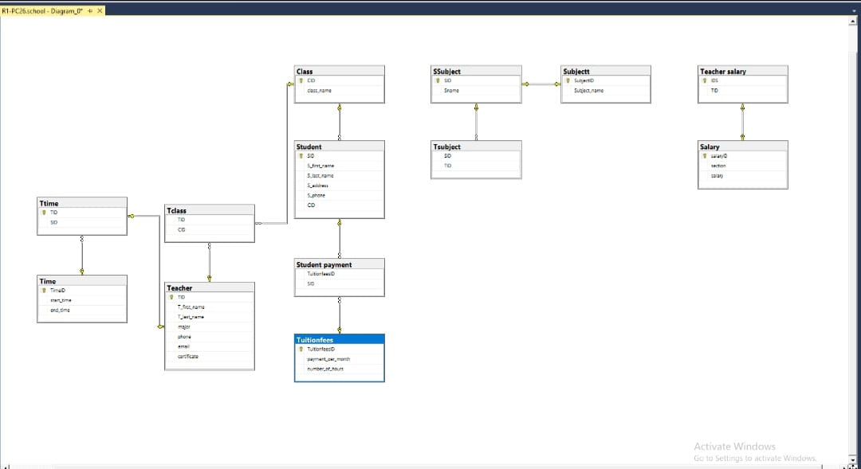

Figure 1

Home page



Figure 2

Login page:

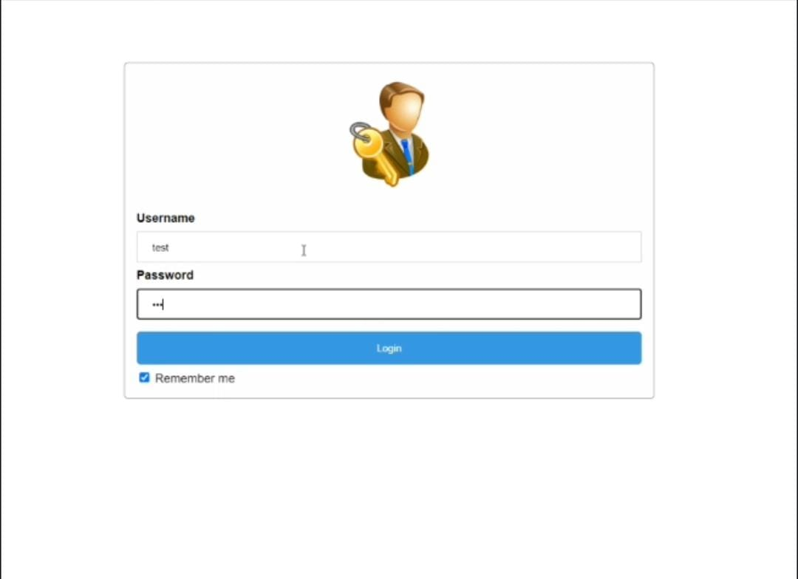

Figure 3

Adding courses:

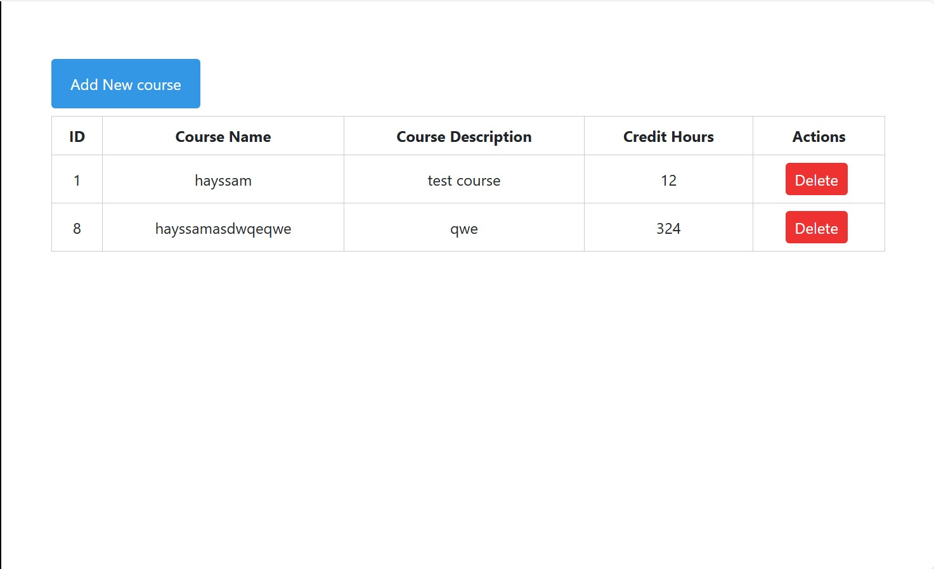

Figure 4

Adding students:

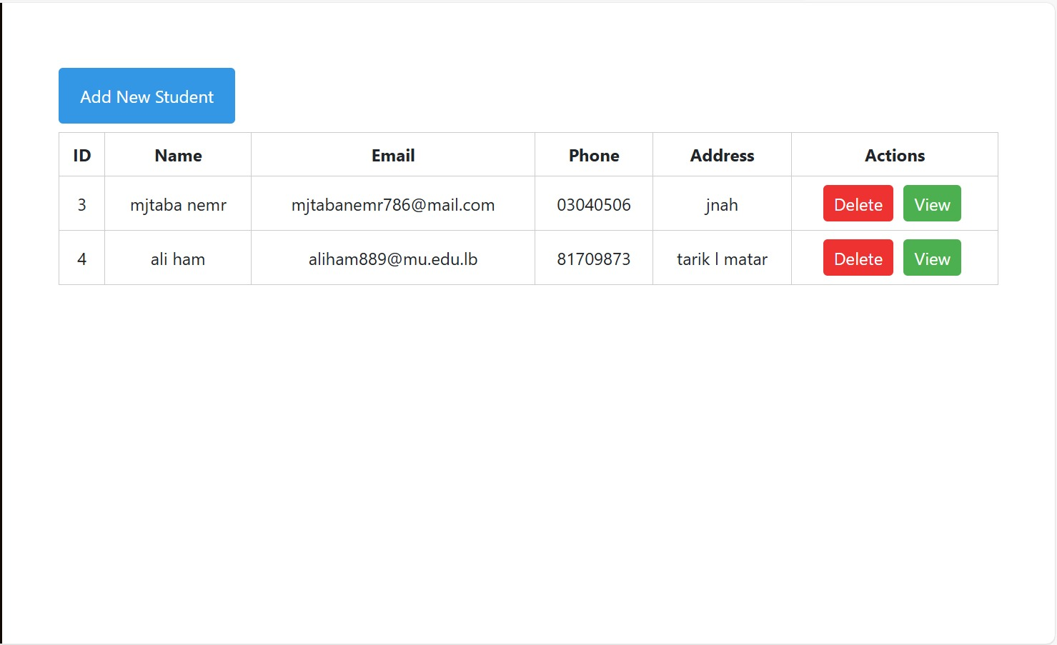

Figure 5

Adding doctors:

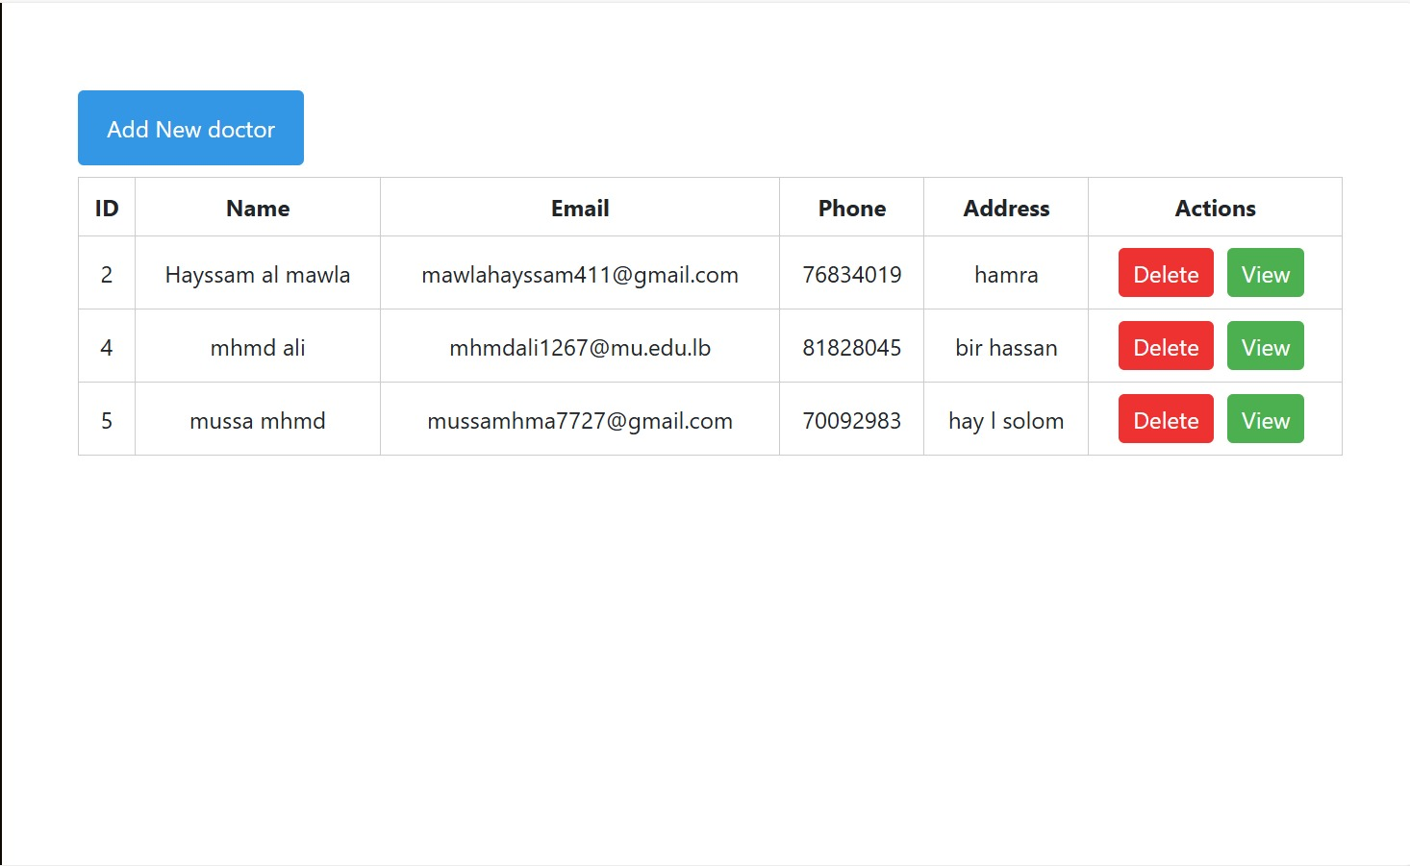

Figure 6

Adding rooms:

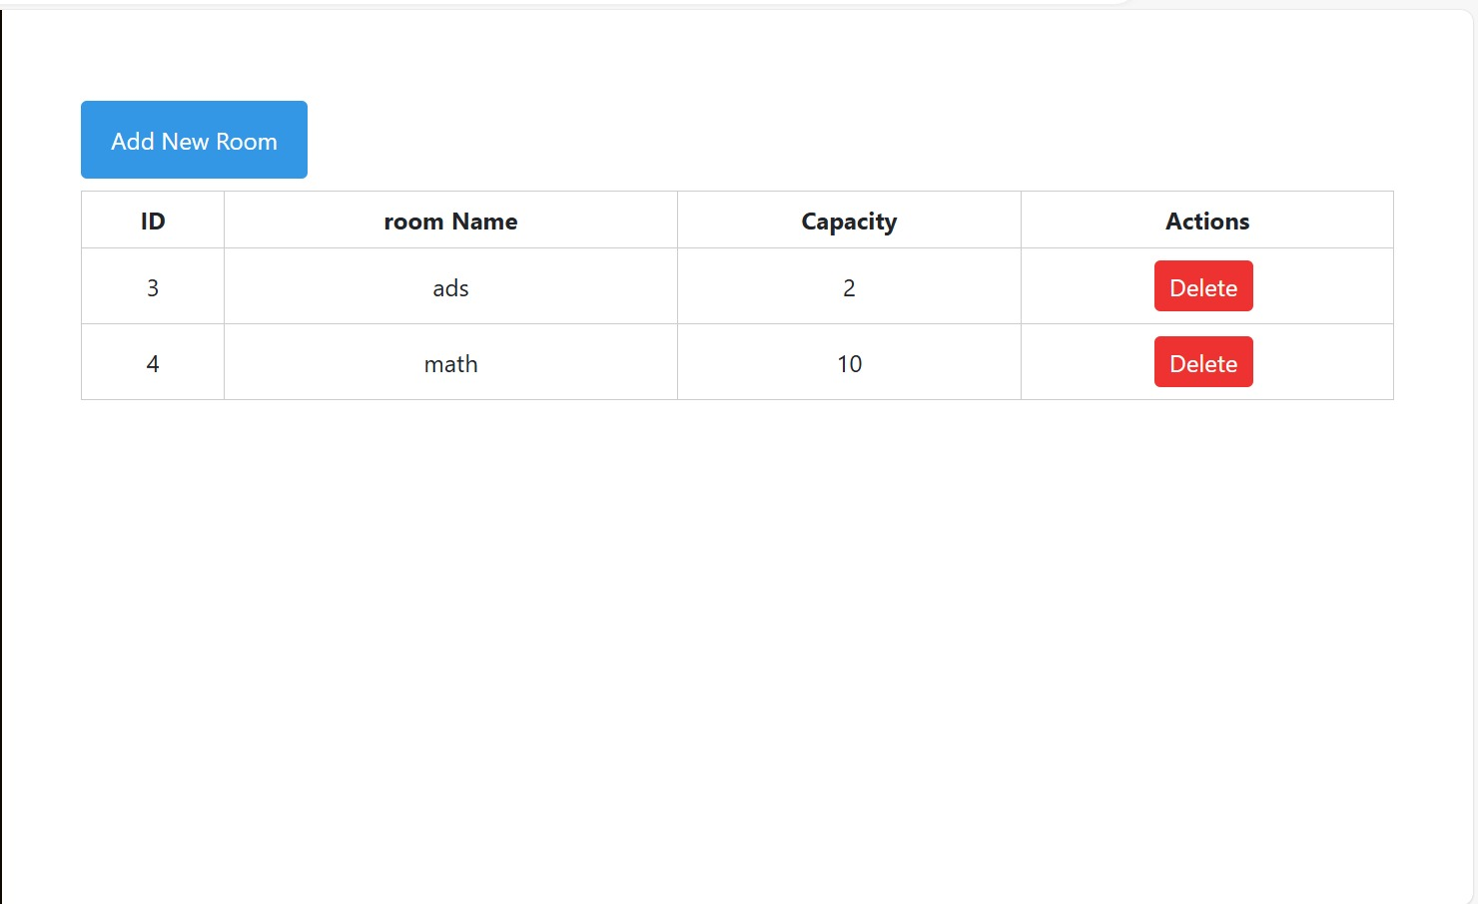

Figure 7

Login as doctor:

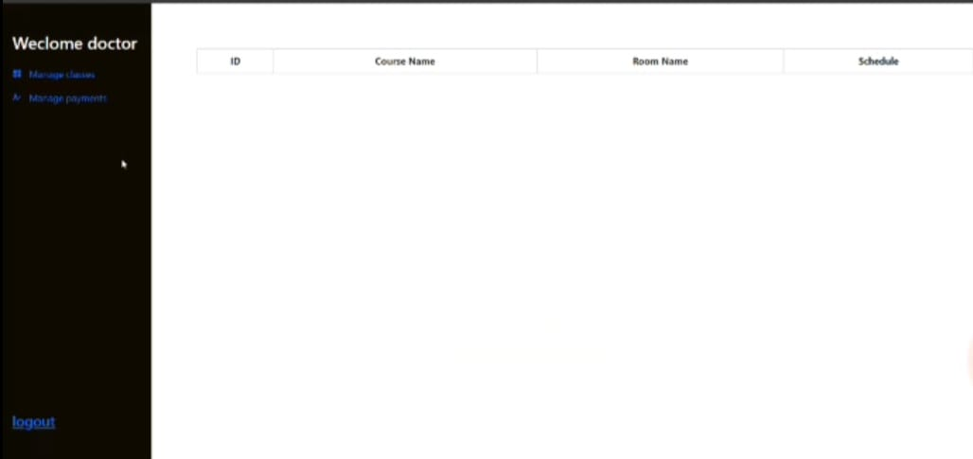

Figure 8

References:

* <https://www.mtu.edu/>
* <https://www.researchgate.net/?_tp=eyJjb250ZXh0Ijp7ImZpcnN0UGFnZSI6InB1YmxpY2F0aW9uIiwicGFnZSI6InB1YmxpY2F0aW9uIn19>
* <https://www.investopedia.com/>
* <https://reference.nlb.gov.sg/>
* <https://www.britannica.com/>
* <http://www.cs.uct.ac.za/>
* <https://en.wikipedia.org/wiki/Main_Page>
* <https://www.freecodecamp.org/>
* <https://en.wikipedia.org/wiki/Main_Page>
* <https://en.wikipedia.org/wiki/Main_Page>